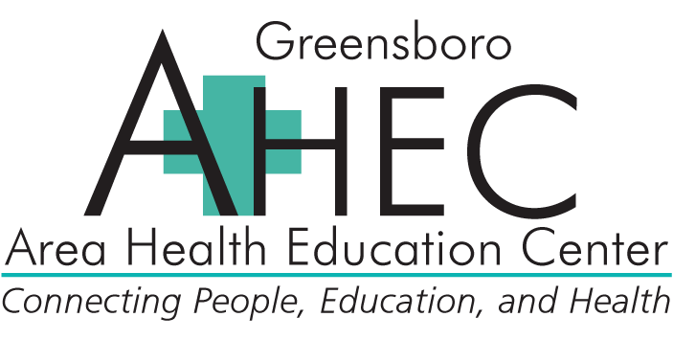

**The 2016 Diabetes Summit**

***(50462)***

Co-Sponsored by Greensboro AHEC and The University of North Carolina Eshelman School of Pharmacy

Event #: 50462-178134(Pharmacist Session)

#### Friday, November 4, 2016

ACPE# 0046-9999-16-202-L01-P

(Pharmacist Session)

8:00 a.m. – 4:15 p.m. (Check-in at 7:30 a.m.)

7.0 contact hours

***Faculty:***

Daniel Bensimhon, MD

Christine McCuen, MD

Ray Coladonato, MD

Laura Watson, MS, RD, LDN

Michael Brennan, MD, CDE, FACE, FAAP

Laura Jobe, RD

Jennifer Badik, MD

***Program Description:***

This symposium is designed to provide educational opportunities for healthcare professionals to gain knowledge about specific topics in the field of adult and pediatric diabetes. It is imperative that healthcare professionals remain educated in all aspects of their patient's care, from the clinical to the behavioral. This knowledge-based activity is designed to provide physicians, nurses, nurse practitioners, physician assistants, pharmacists, dietitians, and other healthcare professionals with the most current trends and treatment strategies for diabetic patients.

***Pharmacist Learning Objectives:***

By the end of this knowledge-based conference, participants should be able to:

* Describe the risk of cardiovascular complications in a patient with diabetes.
* Identify renal complications experienced by diabetic patients.
* Identify vision complications unique to diabetic patients.
* Experience the special daily life challenges of living with diabetes
* Explain the roles of nutrition, weight management, and physical activity for diabetic adult patients.
* Describe the proper use and interpretation of multiple diabetic technologies.
* Discuss the latest oral medications and non-insulin injectables for diabetic patients.
* Explain the roles of nutrition, weight management, and physical activity for diabetic pediatric patients.

***Agenda:***

Agenda:  
7:30am Check-in, Continental Breakfast and Exhibits

8:00am Diabetes and Cardiovascular Disease – Daniel Bensimhon, MD

9:00am Diabetes and Eye Disorders - Christine McCuen, MD

10:00am Break and Exhibits

10:15am Diabetes and Renal Complications – Ray Coladonato, MD

11:15am Patient Panel: An Interactive Discussion

12:15pm Lunch and Exhibits

BREAKOUT SESSIONS:

1:00pm sessions

A) Nutrition Management of Obesity, Type 1 and 2 Diabetes Management in Children and Adolescents - Laura Watson, MS, RD, LDN

B) Update on Oral Medications & Non-Insulin Injectables - Michael Brennan, MD, CDE, FACE, FAAP

2:00pm sessions

A) Nutrition Management of Obesity and Type 2 Diabetes Management in Adults – Laura Jobe, RD

B) Update on Insulins and Pumps – Jennifer Badik, MD

3:00pm Break and Exhibits

3:15pm Panel Discussion & Question/Answer Session - Faculty

4:15pm Adjourn

***Location:***

Moses Cone Hospital - Greensboro, NC

***Target Audience:***

This symposium will be targeted towards primary care physicians, school nurses, nurses, pediatricians, pharmacists, nurses, nurse practitioners, dietitians, and other interested healthcare professionals that care for diabetic patients.

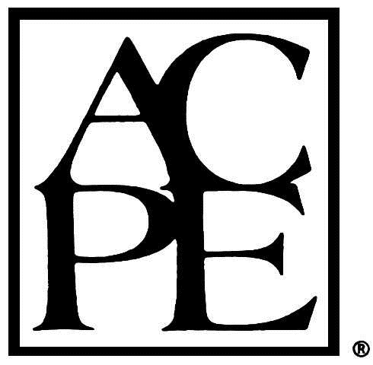**Continuing Education Credit for Pharmacists:**

The University of North Carolina Eshelman School of Pharmacy is accredited by the Accreditation Council for Pharmacy Education as a provider of continuing pharmacy education. The knowledge-based program, ACPE # XXX-XXXX-XX-XXX-XXX-X, will provide 7.0 hours of continuing pharmacy education credit. To receive ACPE credit, attendance must be acknowledged by completing the online evaluation. Statements of ACPE credit can be viewed and printed from CPE monitor on NABP.net. No partial credit will be given

**Pharmacy Coordinator:**

**Jennifer Kim, PharmD**

Assistant Pharmacy Director

Greensboro AHEC

***Fees:***

*$125 Registration Fee*

***Americans with Disability Act:***

It is the policy of the Greensboro AHEC not to discriminate against any person on the basis of disabilities. If you need service or auxiliary aids mentioned in the Act in order to participate fully, please call us at 336-832-8025 at least three (3) weeks in advance of the program.